
YEAR 5 SUPERSTAR CHALLENGE
During this week, you will be visiting your class in small groups to see your teacher and meet your new teacher. When you are not in school, we have set you a challenge! How many of these activities can you do?
You only have Monday, Tuesday and Wednesday! Have fun completing the activities!
Please send all work and photos to homework@shottermill-jun.surrey.sch.uk marked FAO Year 5 teachers.

English  Write a diary entry for a day in the life of a living thing, either a plant or an animal of your choice.  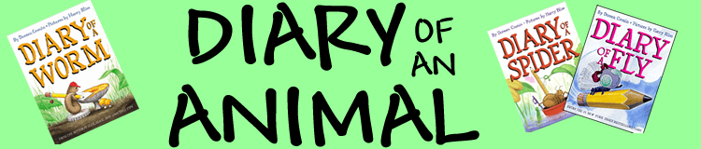    Imagine you are that living thing and try to include some feelings. | English  As the summer holidays are getting close, write a description of your ideal summer holiday in the future tense.    Remember, when you use future tense you need to use words such as ‘I will’ and ‘I would’. | Maths  Draw a rectangular floor plan for a new play area for the playground on squared paper. What is the area of your new design? What about the perimeter?  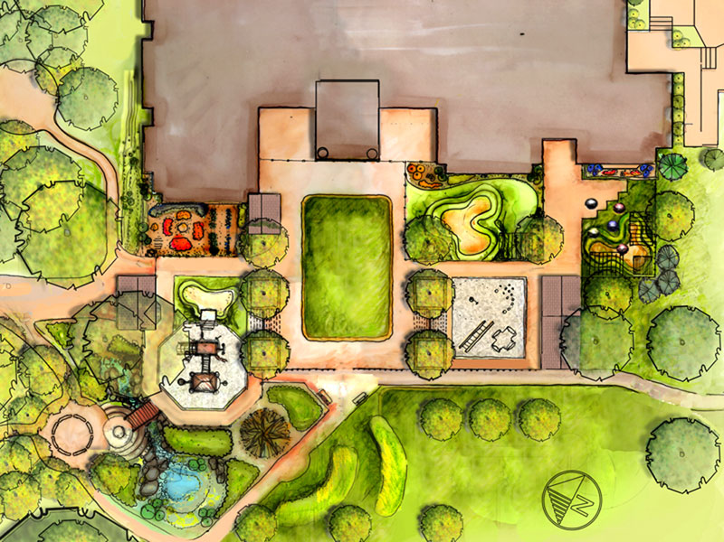  How would you lay out the equipment? Would there be any games painted on the floor? | Maths  Create a maths game using multiplication, division, addition and subtraction. Some ideas you could use are: -    Snakes and ladders  Snap  Connect 4  Guess my number
History  Create a map of an imaginary island.  What natural features will it have? What manmade features? Can you include Ordnance Survey symbols (e.g. Sch = school).  You can create it as a written map or as a 3D model. 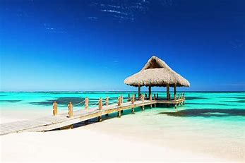 | History  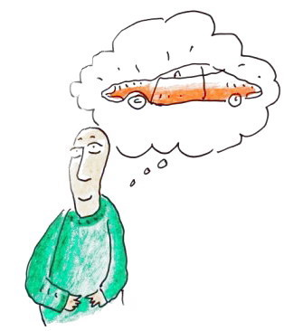  Interview an adult and ask them what transport was like during their childhood and how this has changed. Example questions:  How did you travel to school?  Did your family have a car?  When did you first travel abroad? How did you get there? | 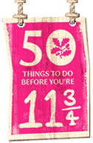  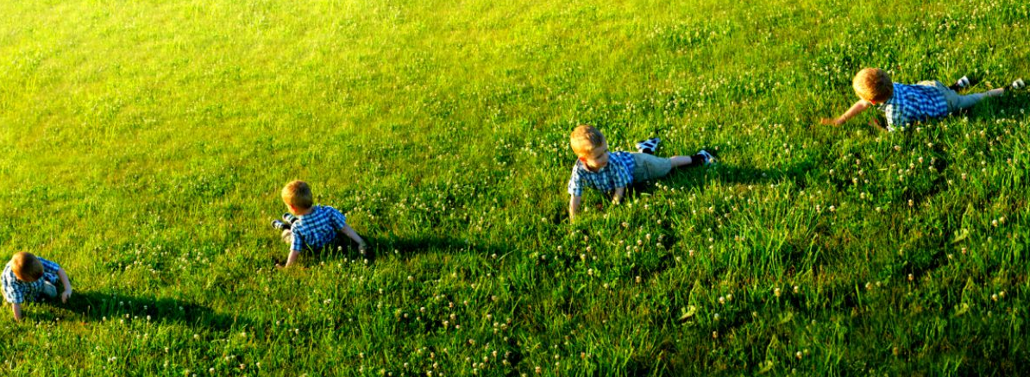  Roll down a really big hill. | Play Poohsticks.  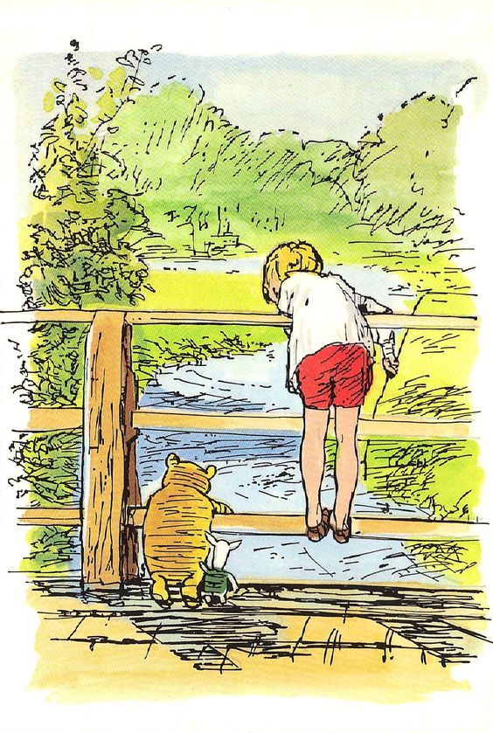  Standing on the side of the bridge that faces upstream (the direction that the water is coming from) count down from 3 and throw the sticks into the stream/river and then quickly run across the bridge and guess whose stick will come out first.
PSHE  It’s not long until you go into Year 5!    Design, make or write instructions for an activity you could do to get to know your peers and new teacher better.  Some ideas to get you started are: a card game, board game, quiz, icebreaker bingo or a storytelling game. | Science  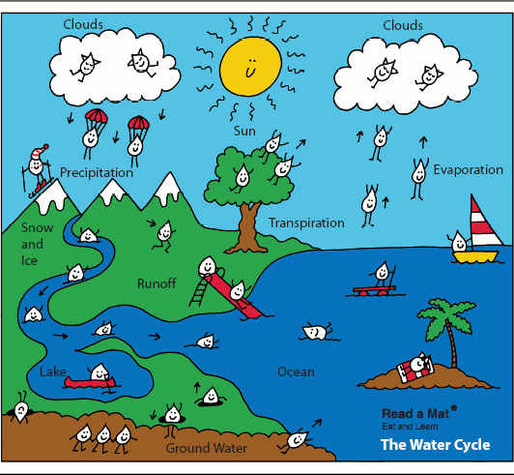  Make a comic strip version of the water cycle using text and pictures. You will need to revise what happens in the water cycle to be able to draw and write about it. | Geography  Using your geographical knowledge quiz on things you have learned this year, create a quiz for your family. You could include questions about rivers, Europe, Italy and Rome and capital cities.   | Music    Carrying on from your music lessons, what can you find from home that would make fantastic percussion instruments. Can you compose a piece of percussion using these instruments?  Extension: Can you add dance moves to your performanc?
French  Find out the names of 10 well-known sports players from French speaking countries. Where are they from and what are they famous for?   | Art  Draw a picture of something that reminds you of being in Year 5 and cut it up to create a jigsaw! Draw the jigsaw pattern first, before you make your picture or download a template from the internet!  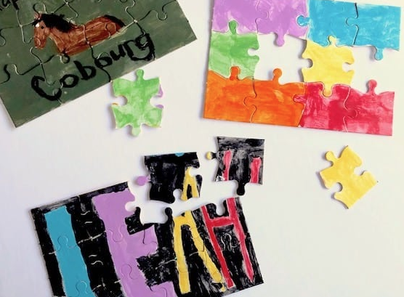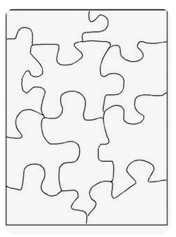 | Design & Technology  Your mission is to build a shelter for two Lego figures. You can use any materials you have to hand!  1. It must be able to withstand a 1 Kg weight being placed on the roof. The two figures must remain protected and undamaged.  2. The two figures must remain dry. This will be judged by placing the two figures on a tissue. The tissue must remain dry when 200 ml of water is poured over the top of the shelter.  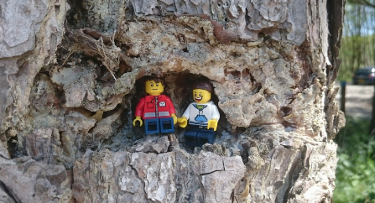 | PE  Create a game you can play that maintains social distancing and the least amount of equipment. E.g. Noodle Tag - Grab at least 3 friends and give everybody a pool noodle. When someone is "it" they have to tag their buddies by using the end of the noodle. Soft and bendy so nobody gets hurt, but also social-distanced approved so no one comes too close!  

